**Improving Emergency Shelter Utilization through Time Series Forecasting**

Deanna Rose Quiambao, Thi Hanh Nguyen Phan, Saran Poocharoen,

Prajwal Nagaraj, Genevieve Ababa

Southern Alberta Institute of Technology (SAIT)

MNGT-257 [V3B] – Business Certificate Capstone

Chanetelle LaMotte

Date of Submission: 23 April 2025

# Executive Summary

Realizing the critical issue of fluctuating shelter demand and vacancies across Calgary, our project called “Improving Emergency Shelter Utilization through Time Series Forecasting” aims to provide real-time tracking of available spaces to enhance the efficiency and accessibility of shelter services in Calgary. Integrating both historical data and real-time analytics, we aim to create a platform that will use advanced data analytics techniques to predict future occupancy trends and help shelter organizations allocate resources effectively. This proactive approach will enable organizations to manage shelter spaces efficiently, ensuring timely and sufficient support for vulnerable populations in need.

Contents

Executive Summary 2

Project Scope, Project Goals/Aims, and Objectives 3

Literature Review 4

Competitive Analysis 6

Project Methodology 9

Team Member Profiles 11

Actual Project Resources and Budget 14

Actual Risk and Issue Management Plan 14

Stakeholder Communication Plan 16

Product / Service Development Plan with MVP or Prototypes to Validate 16

Timeline 22

Deliverables (Outputs) Executed 22

Results and Analysis: Forecast Analysis: 2025 - 2026 28

Conclusion: 31

Lessons Learned: 32

References 36

Appendices: 37

# 

# Project Scope, Project Goals/Aims, and Objectives

**Project scope**: The project will focus on providing shelter organizations in Alberta with a real-time, data-driven solution to track shelter vacancies. This will include the integration of real-time vacancy data and predictive analytics that enable organizations to plan and allocate resources effectively. The scope will cover:

* Real-time tracking of shelter vacancies.
* Predictive modeling for occupancy rates based on historical and real-time data.
* Actionable insights for shelter organizations to address fluctuations in demand.

**Project Goals/Aims and Objectives:** Our main goal is to provide shelter organizations with appropriate actionable, driven-date plans that will help the organizations enhance the efficiency and effectiveness of shelter allocation. Our objectives include leveraging our knowledge and experience in data analytics to create a user-friendly platform that enables those organizations to track real-time shelter availability. The platform will help organizations enhance their response to fluctuating demand, prevent overcrowding, and minimize gaps in service. Through these insights, we also help organizations create proactive action plans, allowing them to respond more effectively to emergencies, seasonal changes, and surges in demand. Ultimately, the platform will improve the accessibility and timeliness of shelter services, ensuring that vulnerable populations receive the support they need while maximizing the efficiency of available resources.

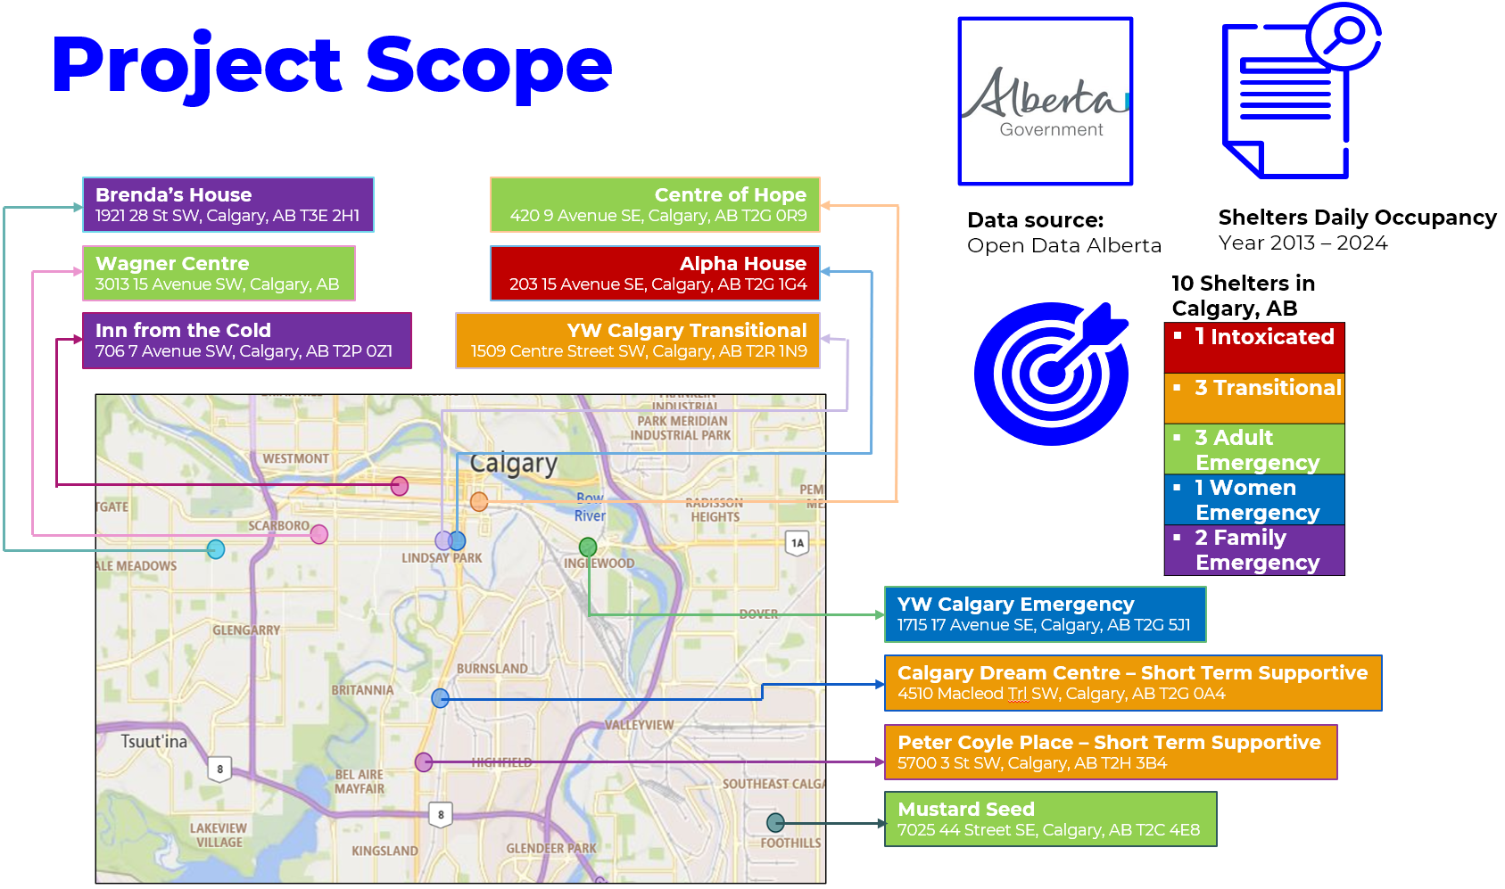

Figure 1: Project Scope (Source: Pitch Presentation)

# Literature Review

The growing demand for emergency shelter services in Alberta has prompted efforts to enhance both accessibility and operational efficiency. Existing tools, such as the ShelterLink App and Coordinated Access and Assessment (CAA) systems, provide real-time tracking of bed availability; however, they lack the predictive capabilities essential for proactive planning. ShelterLink enables participating shelters to report real-time bed availability, facilitating immediate assistance for women and children fleeing domestic violence (FearIsNotLove, n.d.). Similarly, CAA systems direct individuals experiencing homelessness to community access points where trained workers assess needs and match them to available housing interventions (Employment and Social Development Canada, 2019). Despite these functionalities, neither system incorporates predictive analytics for future occupancy forecasting. For instance, while DomesticShelters.org offers a comprehensive directory of shelter services, it does not provide real-time data or predictive insights to help shelter staff prepare for demand surges (DomesticShelters.org, n.d.). This gap underscores the need for integrating predictive analytics into existing systems to enhance emergency shelter planning and responsiveness.

Research supports the use of time series forecasting in public service contexts. Herder et al. (2021) demonstrated how algorithms such as ARIMA and Prophet significantly improved resource planning accuracy in social housing. According to Gartner (2023), states that over 75% of nonprofit organizations are expected to adopt predictive analytics by 2026 to optimize resource distribution and decision-making. These findings validate our approach to integrating forecasting into shelter service operations. Moreover, Statistics Canada (2024) reported a 20% seasonal increase in shelter occupancy during colder months, further emphasizing the need for tools that forecast demand. The Canadian Observatory on Homelessness (2023) also noted that shelters operating at or above 90% capacity are at a high risk of turning clients away—an issue that predictive models could help mitigate.

The Government of Alberta provides open datasets on daily emergency shelter occupancy, which can be used to develop predictive models. Based on these insights, the proposed MVP includes a Power BI dashboard for real-time tracking, a time series forecasting model built using Python or R, and an actionable resource allocation plan. This integrated system addresses an evident gap in current solutions and aligns with emerging trends in data-driven social services.

# Competitive Analysis

Our competitive analysis demonstrates the positioning of our project in the market. This includes the evaluation of how our platform compares with existing solutions and identifies key factors that influence its adoption and success. We have used tools to analyze this, such as PESTLE, SWOT, and Porter’s Five Forces, as we assess external market conditions, internal strengths and weaknesses, and industry competition all surrounding the project.

**PESTLE Analysis**

|  |  |
| --- | --- |
| **Political** | * Government funding support * Changes in political priorities * Changes in homelessness policies * Compliance to privacy and data protection laws |
| **Economic** | * Shifts in government funding * Economic downturns * Availability of resources * Limited budget of shelters |
| **Social** | * Public awareness and support * Interest and adoption of the tools and app * Increasing pressure on organizations to meet social goals * Varying levels of readiness to adopt the app |
| **Technology** | * Use of advanced data analytics techniques * Data sharing among platforms * Integration of existing systems of the organizations * Compliance with privacy and data protection laws |
| **Legal** | * Compliance with legal requirements such as PIPEDA in Canada * Clear terms of use and disclaimers * Data sharing agreements |
| **Environment** | * Shelter operations compliance with environmental laws * Sustainability practices * Surge in shelter demand due to natural disasters or extreme weather |

**Summary:** The project has strong potential, benefiting from political support for homelessness and public awareness. However, it faces challenges such as fluctuating **government funding**, **economic downturns,** and **limited shelter budgets of organizations.** There is an increasing pressure to meet goals, but shelters’ **readiness** to adopt the platform may vary. Addressing these factors will be key to the platform’s success.

**SWOT Analysis**

|  |  |
| --- | --- |
| **Strengths** | **Weaknesses** |
| * Predictive Analytics using Time Series * Comprehensive View of Shelter Occupancy * Scalability and Adaptability of the App to other Regions in Canada * Aid in the improvement of resource allocation * Increase accessibility of Individuals and Families in need of Shelter Support * Comprehensive data reporting of all shelters in Alberta * User-friendly app for users and shelters | * Accuracy of the forecasting models * Limited data features * Potentially overwhelming data for users |
| **Opportunities** | **Threats** |
| * Expansion to other Regions in Canada * Support from Partners, NGOs, and other Government Institutions * Collaboration between various service providers * Advocacy for policy changes * Support in the improvement of the lives of homeless populations * Replication of the same system within other vulnerable communities * Integration with social services for a more holistic solution | * Data Input Errors from participating shelters * Gaps in Data Collection * Data Quality in the Future * Decrease participation of shelters in the data reporting * Resistance of shelters to adopt the user-friendly app * Presence of existing shelter systems Shelterlink App, HMIS, ShelterSafe CAA) |

**Summary:** The project uses predictive analytics to improve shelter management and resource use, with great potential to expand across Canada. It aims to make shelters more accessible and efficient for those in need. However, challenges like ensuring accurate predictions, fixing data issues, and getting shelters to adopt the platform must be tackled. Risks related to data quality, participation, and competition from other systems could affect success. The platform can greatly improve shelter access and resource management for vulnerable people by addressing these challenges.

**Porter’s Five Forces Analysis**

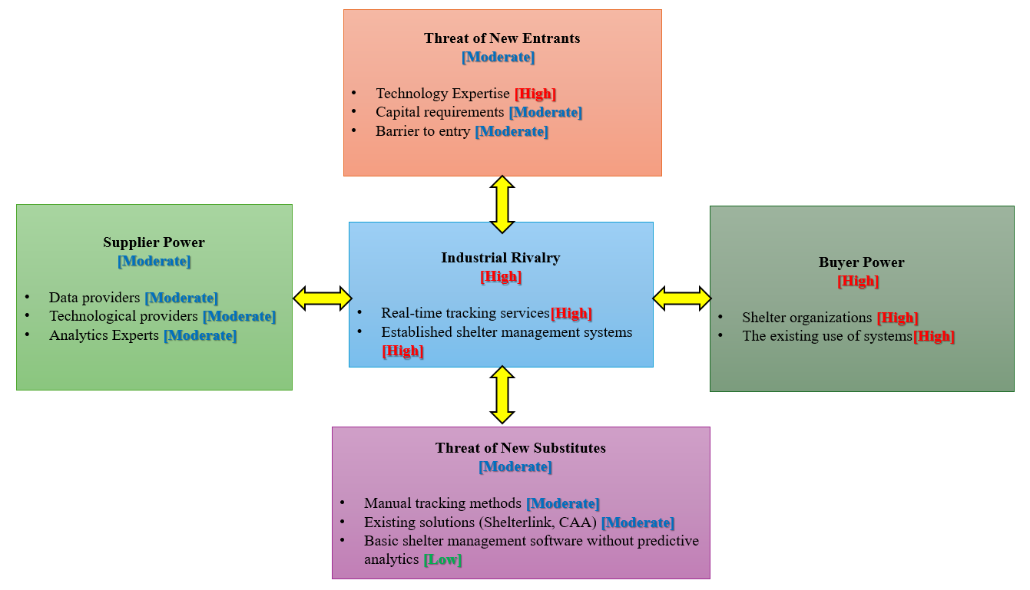

Figure 2: Porter's Five Forces Analysis

**Summary:** The above Five Forces Analysis highlights high industrial rivalry due to established shelter management systems and real-time tracking services, alongside strong buyer power from shelter organizations mostly reliant on existing systems. The moderate threat of new entrants and substitutes suggests barriers like capital requirements and technology expertise, while alternatives such as manual tracking and basic software lack predictive analytics. Supplier power remains moderate, with data, technology, and analytics providers holding some influence but not dominating the industry.

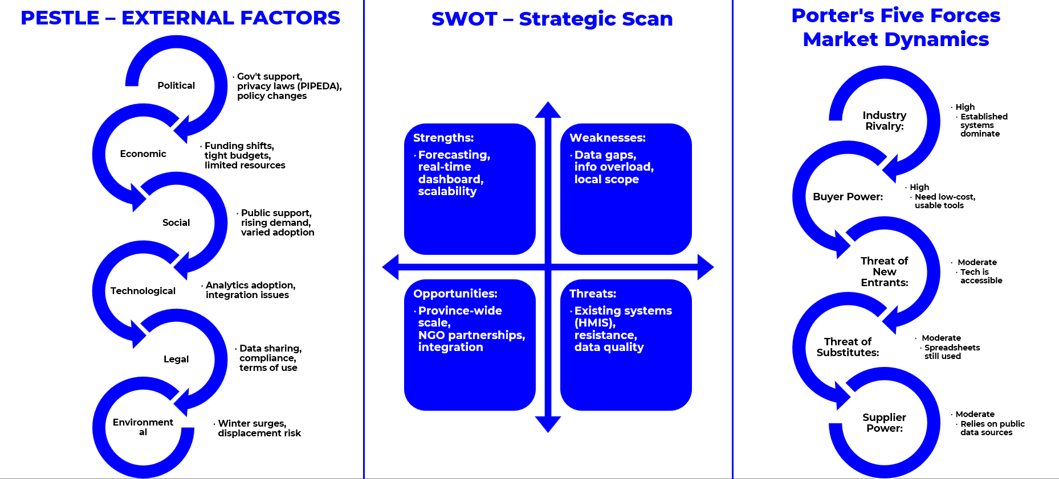

Figure 3: Competitive Analysis Summary

**Why Are We Different**

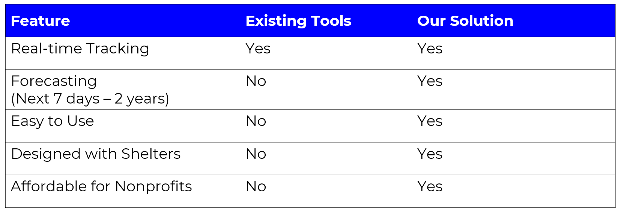

Figure 4: Why are we different

# Project Methodology

The Agile methodology was chosen as it is a natural fit with our project, which is iterative, and we need to collaborate with the stakeholders. Since a real-time forecasting platform requires an agile environment, its strength is in flexibility, rapid feedback loops, and the ability to adapt to changing requirements.

**How Agile Works in Our Project**

Agile methodology involves continuous, incremental progress through short iterative cycles known as "sprints." Each sprint delivers a working component of the platform, ensuring we regularly receive feedback from our stakeholders to refine and enhance our final deliverable.

Steps and Procedures:

1. **Planning & Requirements Gathering (Sprint 0):**
   * Define clear requirements through brainstorming sessions and meetings.
   * Conduct interviews and meetings with the mentor.
   * **Participants:** Project team, YW Calgary representatives, and instructor.
2. **Iterative Development & Design:**
   * Conduct weekly development cycles (sprints lasting 1–2 weeks each).
   * Build the platform incrementally:
     + **Sprint 1–2:** Develop and refine the forecasting model (R-based) using historical shelter data (2013–2024).
     + **Sprint 3–4:** Create and refine the Power BI dashboard interface, integrating real-time data visualization.
   * **Participants:** Project team, technical advisors, and data science mentors.
3. **Testing & Refinements:**
   * Perform ongoing testing within each sprint to verify functionality, usability, and predictive accuracy.
   * Organize regular sprint reviews and retrospectives to identify areas needing improvement.
   * **Participants:** project team
4. **Stakeholder Reviews & Continuous Feedback:**
   * Conduct bi-weekly meetings with the mentor for detailed feedback.
   * Refine the platform continuously based on these insights.
   * **Participants:** Project team, Industry mentor
5. **Final Integration & Deployment:**
   * Integrate final changes based on testing outcomes
   * Prepare a final product that includes:
     + An interactive Power BI dashboard for real-time and forecasted occupancy tracking.
     + A predictive model capable of accurately forecasting shelter occupancy.
     + Actionable insights and recommendations for effective shelter resource allocation.
   * Present and demonstrate the final platform to stakeholders and instructors.
   * **Participants:** Project team, Industry mentor

**Where will we work?**

* **Virtual meetings**: Held regularly via Microsoft Teams for stakeholder interaction and internal meetings.

# Team Member Profiles

**Deanna Rose Quiambao**

Deanna is a dynamic and driven data enthusiast with a solid foundation in data analytics and statistics. She moved to Canada from the Philippines to pursue her Post Diploma Certificates at Southern Alberta Institute of Technology, adding to her impressive Bachelor of Science in Mathematics, majoring in Statistics from Pangasinan State University.

With almost five years of experience as a Statistician, Deanna has honed her skills in statistics, data analysis, and report writing. She's adept at using R and Python, along with tools like SPSS, Microsoft Power BI, Tableau, and SQL for cutting-edge data visualization and analysis.

In addition to her technical prowess, Deanna has a heart for service, currently working as a Community Support Worker, where she supports indigenous children, youth, and adults. During her free time, she likes to hike and explore different places!

**Thi Hanh Nguyen Phan (Moka)**

Thi, or “Moka” as what others call her, is a Vietnamese international student in Canada, passionately pursuing a Post-Diploma Certificate in Data Analytics and a Certificate in Management and Leadership at the Southern Alberta Institute of Technology (SAIT). With over 13 years of experience in the finance and banking sector, Moka has specialized in financial risk management. Her decision to dive deeper into data analytics stemmed from a realization: mastering data skills can significantly enhance her ability to analyze financial issues and manage risks more effectively.

Moka’s dedication to her studies is evident in her outstanding academic performance in her Data Analytics program. As a research enthusiast, she consistently goes the extra mile, blending her extensive financial expertise with cutting-edge data analysis techniques.

**Saran Poochareon**

Saran is an electrical engineer with a passion for leveraging analytical expertise and technical skills to drive informed decision-making and enhance organizational efficiency. With over 15 years of experience in the mobile network and digital services industry in Thailand, he has developed a strong foundation in business strategy, operations, and technology-driven solutions.

Seeking to deepen his expertise and transition into a full-time data analytics role, Saran embarked on a new journey in Canada, where he is currently in the final semester of the Data Analytics + Management and Leadership program at the Southern Alberta Institute of Technology. His academic pursuits complement his hands-on experience, equipping him with advanced analytical tools and leadership skills essential for data-driven decision-making.

Beyond academics, Saran is committed to gaining real-world experience and broadening his global perspective. Living abroad with his family has been a transformative chapter, providing him with invaluable insights into diverse work environments and cultures. He is eager to apply his skills to solve complex challenges, optimize processes, and contribute meaningfully to data-centric organizations.

**Ma Genevieve Ababa**



Genevieve has over 10 years of experience in HR and Administration in the Philippines, working in both the non-profit and restaurant sectors. Her background includes leading teams, managing daily operations, and supporting community-based initiatives—especially during times of crisis. She takes pride in creating a positive work environment and ensuring that people and processes are well taken care of.

Now studying Business and Entrepreneurship in Canada, Genevieve chose this path not because she’s passionate about data analytics but because she wanted to challenge herself, adapt to global standards, and gain new tools to grow professionally. She focuses on practical, people-first solutions that make a real difference in everyday life. With her experience and education combined, Genevieve is excited to explore new opportunities where she can continue supporting others, improving systems, and contributing to meaningful, community-driven work.

**Prajwal Nagaraj**

Prajwal is a curious, data-driven professional who enjoys connecting with people and solving problems. Originally from Bangalore, India, he moved to Canada to explore new opportunities and grow in his career. He’s currently wrapping up his second Post Diploma Certificate in Management and Leadership at SAIT, after completing one in Data Analytics.

He spent two years at Accenture as a Quality Engineering Associate, working with global clients in the banking sector. Over time, he discovered a passion for turning data into insights that help businesses work smarter. He’s comfortable working with tools like Python, SQL, Power BI, and Tableau and loves using them to make sense of complex information and improve how things run.

Prajwal is known for being adaptable, thoughtful, and eager to learn outside of work and school. He’s currently working in retail to support his studies while preparing to move into data, strategy, or consulting corporate roles. In his free time, he enjoys playing video games, traveling, exploring different cultures, and connecting with others through mentorship and meaningful conversations.

# Actual Project Resources and Budget

|  |  |  |  |  |  |
| --- | --- | --- | --- | --- | --- |
| **No./ID** | **Description of Item** | **Qty** | **Cost/Item** | **Total** | **Budgeted** |
| 1 | Power BI Pro License  (Free for students) | 5 | $0 | $0 | ✔ |
| 2 | R-Studio  (Open Source - Free) | 5 | $0 | $0 | ✔ |
| 3 | Research Article Access  (via SAIT) | 5 | $0 | $0 | ✔ |
| 4 | Marketing Material for Final Report | 5 | $0 | $0 | ✔ |
| 5 | Cloud Storage  (Google Drive, 3-months) | 1 | $0 | $0 | ✔ |
| 6 | Contingency Fund | - | - | $0 | ✔ |
| 7 | Capcon Print outs  (Free from Library) | 20 | $0 | $0 | ✔ |
| Total Estimated | | | | $0 |  |

# 

# Actual Risk and Issue Management Plan

| **Description of Risk** | **Impact** | **Risk Control/ Mitigation** | **Severity** | **Comment** |
| --- | --- | --- | --- | --- |
| Data Inaccuracy or Inconsistency | Misleading forecasts may result in improper resource allocation. | Implement data validation processes, cross-check data with multiple sources, and use real-time updates with quality control measures. | High | Partner with shelter organizations to improve data collection standards. |
| Dependence on External Data Sources | Changes in data availability or quality from the City of Calgary could disrupt forecasts. | Develop a contingency plan with alternative data sources (e.g., direct data from shelters and other government agencies). | High | Regularly monitor updates from the City’s open-data portal and adjust models accordingly. |
| Lack of User-Friendly Interface | Poor usability may discourage shelter staff from using the platform. | Conduct user testing and gather feedback for UI/UX improvements. | Medium | Involve shelter staff in the design process for better adoption. |
| Legal & Compliance Issues | Regulatory non-compliance may lead to fines or shutdowns. | Ensure the platform adheres to provincial and federal data protection laws. Consult legal experts. | Medium | Keep up to date with changing regulations and update policies accordingly. |
| Stakeholder Resistance to Adoption | Low adoption of the platform could limit its impact. | Provide training, conduct regular feedback sessions, and demonstrate the tool's benefits. | Medium | Start with a pilot program to build confidence. |
| Government Policy Changes Affecting Shelter Operations | Any shift in municipal or provincial policies (e.g., funding changes and new regulations) may impact shelter management. | Maintain regular communication with policymakers and stay updated on regulatory changes. | High | Adjust system recommendations dynamically based on policy updates. |
| Integration Issues with Existing Shelter Systems | Delays in implementation or incomplete data feeds may hinder effectiveness. | Conduct a system compatibility study before integration and provide API support for seamless data exchange. | High | Offer technical support and work closely with IT teams. |
| Unforeseen Demand Surges (e.g., pandemics, economic downturns) | Shelters may become overwhelmed, reducing accessibility for those in need. | Design the system to include emergency protocols and predictive models that consider crisis scenarios. | High | Collaborate with emergency response teams for contingency planning. |
| Reliability of Forecast Models in Real-World Application | Forecasts may not fully capture unexpected events like extreme weather or sudden economic changes. | Include scenario-based planning and stress testing for unusual events. | Medium | Collaborate with emergency response teams to improve predictive accuracy. |

# Stakeholder Communication Plan

| **Stakeholder (Who)** | **Communication Channel (How)** | **Key Interests and Issues (About What)** | **Frequency (How Often)** | **Comments/ Links** |
| --- | --- | --- | --- | --- |
| **Shelter Management & Staff**  **(Industry Mentor- Randy Thornhill, YW Calgary)** | Emails, Virtual/ In-Person Meetings, and Dashboards | Shelter occupancy trends, resource allocation, system updates, emergency planning | Bi-weekly meetings | Ensure reports highlight key insights and actionable recommendations |
| **Frontline Workers & Caseworkers** | Emails, Virtual/ In-Person Meetings | Real-time shelter availability, case updates, emergency response protocols | As needed | Keep communication concise and actionable |
| **Residents & Clients** | Shelter Bulletin Boards | Shelter availability, service access, emergency notifications, community resources | As needed | Ensure updates are available in multiple languages and accessible formats |
| **Government Agencies & Public Services** | Official Reports | Policy compliance, impact assessment, shelter occupancy trends | As needed | Ensure compliance with government reporting standards and policy updates |

# Product / Service Development Plan with MVP or Prototypes to Validate

1. **The Shelter Occupancy Dashboard**

The Shelter Occupancy Dashboard is a monitoring tool designed to provide up-to-date insights into the occupancy rates, capacity, and utilization of various shelters in Calgary. It helps shelter managers, policymakers, and service providers track shelter utilization and identify trends. It aims to analyze the historical data of each shelter by identifying over-occupied or under-occupied shelters. The past trends of these shelters are helpful to gain insights on long-term utilization. It is essential to track this behavior as it affects the future bed availability of the shelters.

Figure 5: Power Bi Dashboard

**Link to Access:** [***https://app.powerbi.com/links/0-YCl6BC8x?ctid=f52f2183-9f67-4ad2-b656-6f754fe196cb&pbi_source=linkShare***](https://app.powerbi.com/links/0-YCl6BC8x?ctid=f52f2183-9f67-4ad2-b656-6f754fe196cb&pbi_source=linkShare)

1. **The Shelter Occupancy Forecasting Web Application**

The Shelter Occupancy Forecasting Web App is a user-friendly application that uses predictive analytics that estimates future shelter occupancy rates of shelters for the next 730 days (2 years). Developed using R programming language, the model called Seasonal and Trend Decomposition using ARIMA (Auto-Regressive Integrated Moving Average) model was used to analyze the historical data and generate forecasts of the occupancy rates of various shelters. ARIMA is particularly effective for predicting occupancy trends because it accounts for both long-term patterns (trends) and short-term fluctuations (seasonality), making it highly reliable for dynamic environments like shelters.

This web app assists shelters and policymakers in preparing for future fluctuations, preventing overcrowding, and ensuring that resources are allocated efficiently. Its key features include scenario analysis, forecast values, interactive graphs, and web-based accessibility, making it an essential tool for data-driven decision-making in homelessness management.

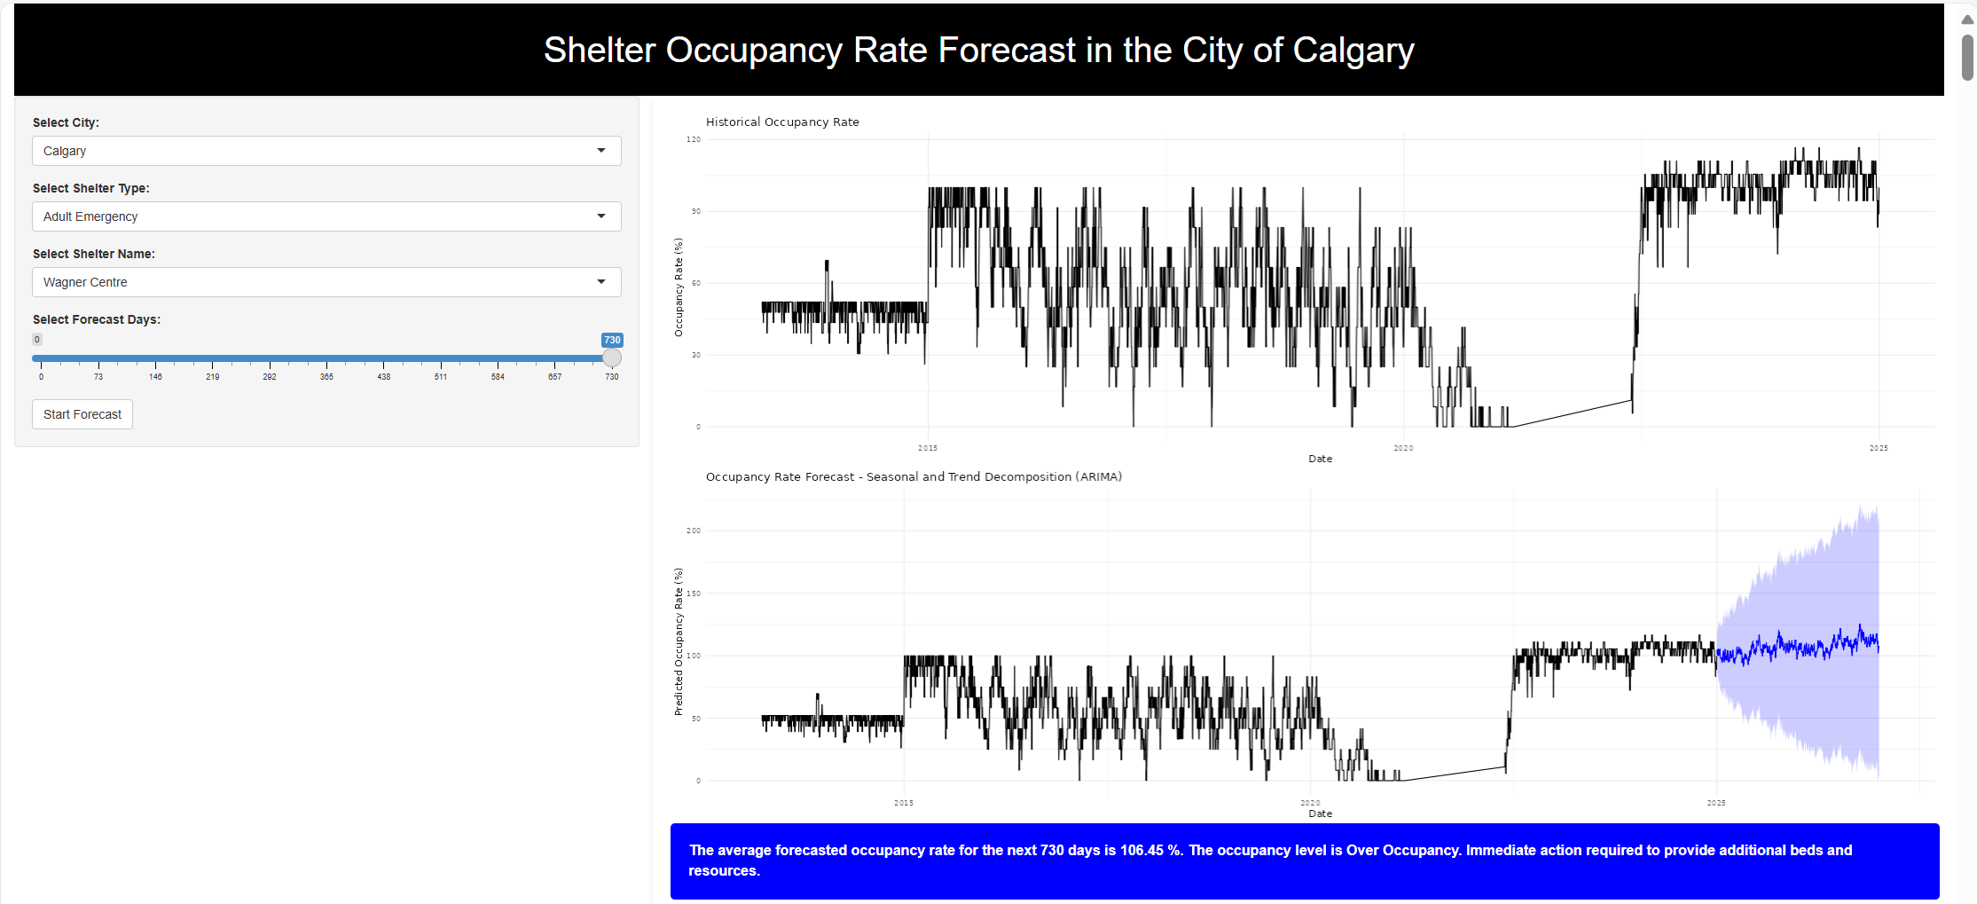

Figure 6: Shiny App (Web App)

**Link to Access:** [***https://firstconsultinggroup.shinyapps.io/ShelterOccupancyForecast/***](https://firstconsultinggroup.shinyapps.io/ShelterOccupancyForecast/)

1. **The Action Plans**

We create specific categories based on different occupancy levels of shelter demand. These categories help organizations determine the emergency level for responsive strategies, ensuring that the strategies are appropriate and effective for the specific demand at any given time.

|  |  |  |
| --- | --- | --- |
| **Occupancy level** | **Occupancy rate** | **Notes** |
| **Low Occupancy** | **< 60%** | **Underutilized resources** |
| **Moderate Occupancy** | **60% - 85%** | **Normal operations** |
| **High Occupancy** | **85% - 100%** | **Risk of overcrowding** |
| **Over Occupancy** | **>100%** | **Need more beds immediately** |

Based on the forecasting data for occupancy rate using our predictive model and the above categories, we suggest response strategies for shelters:

| **GOAL** | **ACTIVITIES** | | **DEADLINES** |
| --- | --- | --- | --- |
| **CRITICAL OVER-OCCUPANCY SHELTERS**  **Alpha House | Wagner Center | Mustard Seed**  **Intox | Adult Emergency | Adult Emergency** | | | |
| Allocate funding for possible expansion of shelter spaces | 1 | Request additional funding from stakeholders for possible expansion of shelter spaces (i.e. Government of Alberta, Partners, Sponsors, Donors, etc.) | NLT 3rd Quarter  Year 1 |
| 2 | Secure temporary shelter spaces, such as hotels or private-market apartments, to provide immediate relief and increase capacity. | Year 1 |
| Increased partnerships with other emergency shelters in the city | 1 | Collaborate with other emergency shelters within the city to facilitate the referral of clients and adopt housing-first support approach. | Continuously |
| 2 | Participate in the Service Hub Model program led by the GoA to establish referral of individuals experiencing homelessness to a wider range of resources. | Year 1 |
| Improve case management of the clients in the shelter | 1 | Review the Average Length of Stay (ALOS) at the shelters and determine specific clientele who have overstayed their intended shelter duration. | Within 1st Quarter  Year 1 |
| 2 | Establish a seasonal staffing pool and maintain a list of well-trained on-call staff, while complying with the standard case management ratio to client. | NLT Year 2 |
| Conduct Future Studies and Innovations | 1 | Conduct comprehensive future studies to assess additional factors that influence the demand for shelter services, such as economic trends, seasonal fluctuations, and client needs. | Year 1 |
| **HIGH OCCUPANCY SHELTERS**  **Peter Coyle Place | Centre of Hope | Calgary Dream Centre | YW Transitional| YW Emergency | Inn from the Cold**  **Transitional | Adult Emergency| Transitional | Transitional | Women Emergency| Family Emergency** | | | |
| Develop and implement new strategies for better tracking | 1 | Utilize the Web app to track the occupancy rate for one week in advance. | Weekly |
| 2 | Develop and implement more effective planning and resource allocation based on the tracking of occupancy rate weekly. | Quarterly |
| Utilize the capacity more effectively | 1 | Develop the resource allocation plans (staff, facilities…) during underused capacity. | Quarterly |
| 2 | Coordinate with other housing partners to utilize underused capacity using the predictive occupancy rate from the Web app. | Continuously |
| Understand and communicate progress on shelter demands | 1 | Conduct needs analysis by assessing more factors which can affect shelter demands (seasonal, economic trends, client’s needs…). | Year 1 |
| 2 | Working with community/housing partners to develop and implement a “by-name” list to support coordination of resources and understand changes in shelter demands in Calgary. | Quarterly  Year 1 |
| 3 | Develop communication strategies for regular communication with and receiving information from the community/housing partners for shelter demands. | Quarterly |
| **MODERATE OCCUPANCY SHELTERS**  **Brenda’s House | Family Emergency** | | | |
| Improve Resource Allocation and Capacity Utilization | 1 | Maintain 90% occupancy rate in moderate occupancy shelters with a balance of staff allocation to meet client needs. | Monthly |
| 2 | Ensure that the available shelter spaces are occupied during high-demand periods by coordinating with other community partners. | Year 1 |

*Note: Brendas House Family Emergency Shelter will be closed as of March 31st 2025*

**~~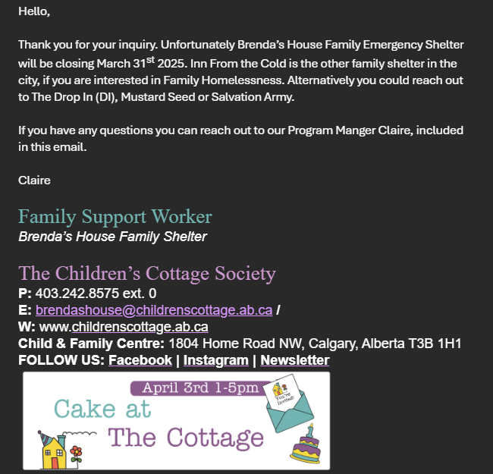~~**

**Stakeholder and Use Case for our Product Data**

| **Stakeholder** | **Use Case** |
| --- | --- |
| **City of Calgary** | Policy design, funding allocation, overflow response plans |
| **Nonprofits & Outreach Teams** | Targeted street outreach, mobile service planning |
| **Healthcare & Addiction Services** | Align resources with anticipated high-risk shelter periods |
| **Emergency Responders (911/EMS)** | Proactive coordination during peak shelter demand |
| **Academia & Analysts** | Research on homelessness patterns and service gaps |
| **Grant Agencies / Funders** | Evidence-based resource deployment and outcome evaluation |

# 

# Timeline

Figure 7: Ghant Chart

# Deliverables (Outputs) Executed

To start the execution stage of our project, we first used the **Shelter Occupancy Dashboard** to analyze the historical trend and seasonality of shelter utilization across various facilities in Calgary. This dashboard provided a comprehensive visualization of occupancy patterns over the past decade (2014–2024), highlighting fluctuations, recurring seasonal trends, and instances of over-occupancy.

**Alpha House**

Shelter Type: Intox

Location: 203 15 Avenue SE, Calgary, AB T2G 1G4

Alpha House has experienced frequent **over-occupancy** from 2014 to 2024. While shelter capacity and utilization have fluctuated, the general trend indicates **over-utilization**. The latest occupancy rate is 110.8%, meaning that the shelter is currently **exceeding its capacity**.

**Brenda’s House**

Shelter Type: Family emergency

Location: 1921 28 St SW, Calgary, AB T3E 2H1

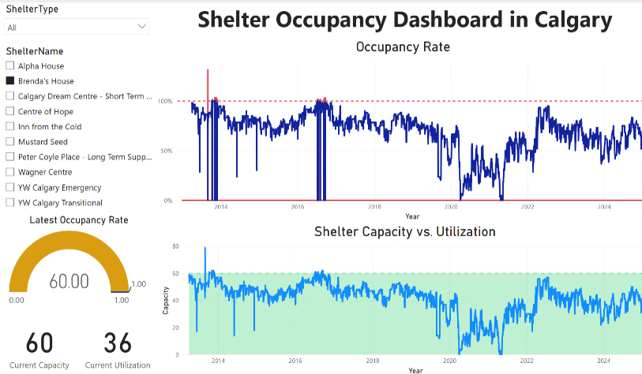Brenda’s House has experienced fluctuations in occupancy from 2014 to 2024, with **occasional over-occupancy** during the year 2014 to 2015. While shelter capacity and utilization have varied, the general trend shows **moderate utilization**. The latest occupancy rate is 60.0%, indicating that the shelter is currently operating **below its full capacity**.

**Calgary Dream Centre-Short Term Supportive**

Shelter Type: Transitional

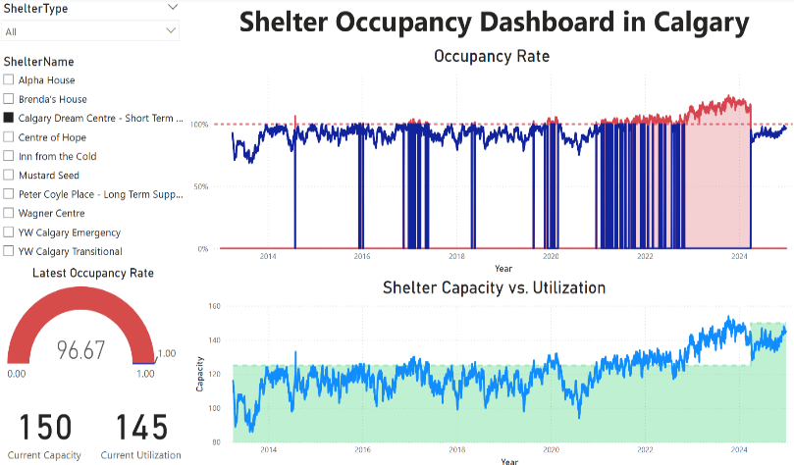Location: 4510 Macleod Trl SW, Calgary, AB T2G 0A4

Calgary Dream Centre has experienced **high occupancy** rates from 2014 to 2024, especially after 2021 with **over-occupancy**.However, the latest occupancy rate is 96.67%, indicating that from the 1st quarter of 2024, the shelter is operating **near full capacity,** and they managed better occupancy.

**Centre of Hope**

Shelter Type: Adult Emergency

Location: 420 9 Avenue SE, Calgary, AB T2G 0R9

There have been fluctuations in occupancy from 2014 to 2024, especially from 2020 to 2021 where the trend is decreasing and increased again by 2022. The Centre of Hope has frequently experienced **over-occupancy** from 2023 to present. However, the latest occupancy rate is 96.36%, indicating that the shelter is currently operating at **high capacity**.

**Inn from the Cold**

Shelter Type: Family Emergency

Location: 706 7 Avenue SW, Calgary, AB T2P 0Z1

An obvious fluctuation in occupancy from 2014 to 2024 has seen. It can be highlighted that Inn from the Cold has experienced **over-occupancy** by season during 3rd and 4th quarters of each year while low utilization during 1st and 2nd quarters of the year. Most of its over-occupancy was seen during the year 2015. The latest occupancy rate is 93.7%, indicating that the shelter is currently operating at **high capacity**.

**Mustard Seed**

Shelter Type: Adult & Women Emergency

Location: 7025 44 Street SE, Calgary, AB T2C 4E8

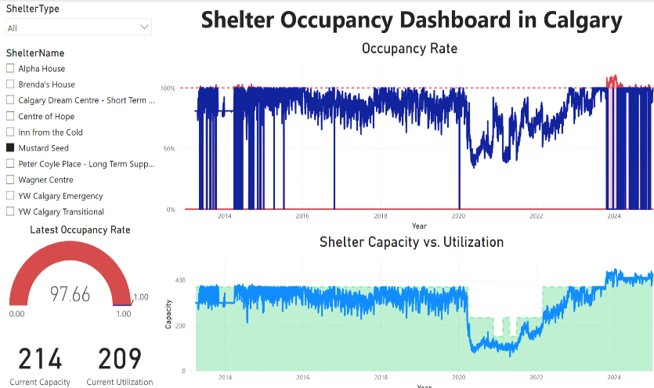From 2013 to 2020, Mustard Seed experienced high occupancy. The trend has decreased by year 2020 and increased again until 2023. Fluctuations have been noted by since. However, it can be highlighted that from 3rd Quarter of 2023, Mustard Seed has experienced **over-occupancy** which was rare for this shelter. The latest occupancy rate is 97.7%, indicating that the shelter is currently operating at**very high capacity**.

**Peter Coyle Place - Short Term Supportive**

Shelter type: Transitional

Location: 5700 3 St SW, Calgary, AB T2H 3B4

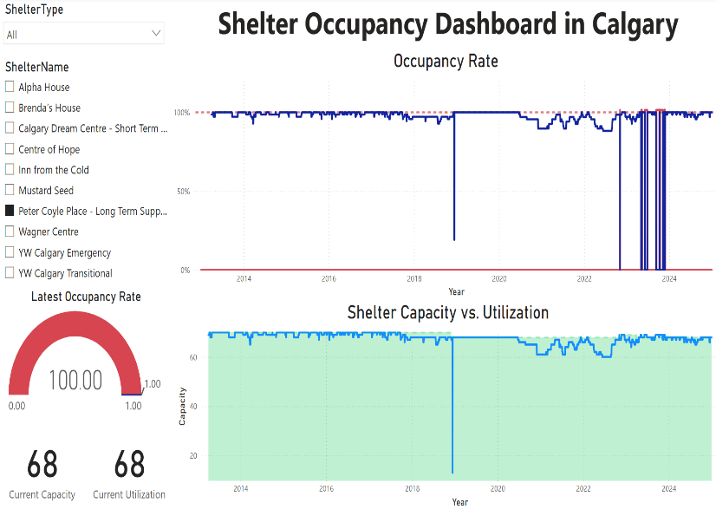Peter Coyle Place has frequently at **full capacity** with no available space from 2013 to 2023 with a rare fluctuation on the beginning of 2019. By year 2023, there are a lot of instances the shelter has fluctuated to very low utilization and increase again after some days. However, it has **hardly experienced over-occupancy**, which mean that it appears to manage occupancy well.

**Wagner Centre**

Shelter Type: Adult Emergency

Location: 3013 15 Avenue SW, Calgary, AB

A stable occupancy rate have been noted for the year 2013 to 2015 but increased dramatically on the middle of 2015. There have been many fluctuations in the occupancy, from 2015 to 2022 along with decreasing trend. Fluctuations up an down was noted from 3rd quarter 2022 to 4th quarter 2024, Wagner Centre has experienced **over-occupancy**. Currently it is at full capacity with no available space.

**YW Calgary Emergency**

Shelter type: Women Emergency

Location: 1715 17 Avenue SE, Calgary, AB T2G 5J1

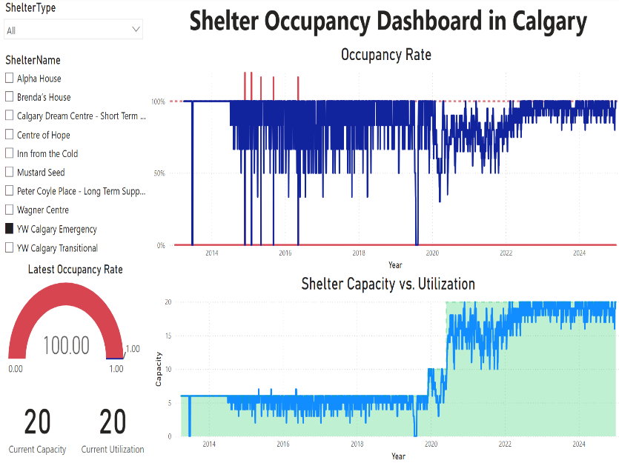YW Emergency has experienced consistent high occupancy level from 2014 to 2024. It doesn’t exceed its capacity most of the years, only on the year 2015 to 2016, there are some days where it exceeds its capacity while the rest of the years, they have a very good management of their beds. Current occupancy rate is 100%, indicating that the shelter is at full capacity with no available space.

**YW Calgary Transitional**:

Shelter type: Transitional

Location: 1509 Centre Street SW, Calgary, AB T2R 1N9

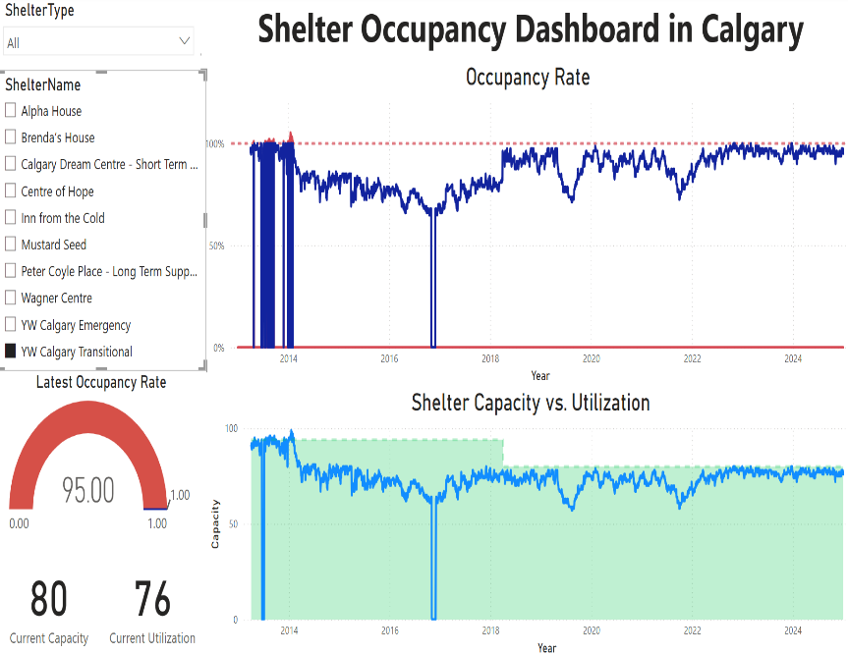YW Transitional has maintained a consistently **high to moderate occupancy rate** but has rarely experienced over-occupancy. It has decreased in occupancy from 2014 to 2017 but managed to utilized its vacancy on the succeeding years. Current occupancy rate is 95% indicating **high utilization**. However, the shelter appears to manage well without any exceeding its capacity.

The 2nd stage of our execution is using the **Shelter Occupancy Forecasting App** to predict the future occupancy rates of the shelters. Using the Seasonal and Trend Decomposition ARIMA model to predict occupancy rates for the next 730 days (2 years), the forecasting model was executed using R programming, enabling precise estimations of future demand for emergency, transitional, and intox shelters. This allowed us to generate detailed shelter-specific occupancy projections, helping policymakers and shelter operators prepare for anticipated capacity constraints.

# Results and Analysis: Forecast Analysis: 2025 - 2026

| **Shelter Type** | **Shelter Name** | **Average Forecasted Occupancy Rates in the Next 2 Years** | **Occupancy Level in the Next 2 Years** |
| --- | --- | --- | --- |
| Intox | Alpha House | 112.49% | Over Occupancy |
| Adult Emergency | Wagner Centre | 106.45% | Over Occupancy |
| Adult Emergency | Mustard Seed | 100.23% | Over Occupancy |
| Transitional | Peter Coyle Place | 99.26% | High Occupancy |
| Adult Emergency | Centre of Hope | 96.43% | High Occupancy |
| Transitional | Calgary Dream Centre | 95.91% | High Occupancy |
| Transitional | YW Transitional | 94.70% | High Occupancy |
| Women Emergency | YW Emergency | 92.99% | High Occupancy |
| Family Emergency | Inn from the Cold | 90.34% | High Occupancy |
| Family Emergency | Brenda’s House | 69.70% | Moderate Occupancy |

The forecasted shelter occupancy rates for the next two years provided critical insights into the capacity constraints of shelters across different shelter type in Calgary. Shelters like **Alpha House, Wagner Centre,** and **Mustard Seed** highlights the urgent need for intervention as they will experience over-occupancy in the next two years. **Alpha House** has the highest projected over-occupancy rate among all shelters, indicating extreme strain on resources. This facility, which serves individuals in need of intoxication management, has historically faced frequent over-occupancy, and this trend is expected to persist. Immediate intervention is needed, including potential capacity expansion, alternative service models, or partnerships with detox programs. **Wagner Centre** is also forecasted to exceed its capacity significantly. Given that it has experienced over-occupancy fluctuations since 2022, the trend highlights systemic demand issues. Strategies such as diversion programs, temporary shelter expansions, or partnerships with transitional housing should be considered. **Mustard Seed** is also expected to exceed its full capacity, putting additional pressure on emergency services. With adult and women’s emergency shelter services, it is critical to evaluate alternative housing options, increased funding, and staffing reinforcement to handle the expected demand.

Furthermore, six shelters such as **Peter Coyle Place, Centre of Hope, Calgary Dream Centre, YW Calgary Transitional, YW Calgary Emergency,** and **Inn from the Cold** are forecasted to operate at above 90% capacity or high occupancy in the next two years. This means that even small fluctuations in demand could push them into over-occupancy. While they are not yet exceeding capacity, they require strategic planning to prevent overcrowding. Any unexpected surge (such as winter demand spikes) could create challenges to these shelters. Proactive management is needed to redirect individuals to alternative shelters or housing solutions before capacity is exceeded. As it is high occupancy, increased funding and expansion of women and adult centered housing programs may be necessary for these shelters. Ensuring smooth transitions and additional housing support programs will be key to maintaining balance.

In the meantime, **Brenda’s House** is the only shelter that is expected to remain at a moderate occupancy level, suggesting some flexibility in capacity. However, given the seasonal fluctuations that family shelters often experience, it remains essential to monitor utilization trends closely to ensure capacity remains manageable. Other family emergency beds can be collaborated with this shelter to partner up with additional housing support programs.

Given these insights, our group focused on creating appropriate action plans for shelters facing the most critical capacity challenges aimed at improving occupancy management and enhancing their service efficiency. These plans aim to enhance service efficiency, optimize resource allocation, and implement long-term solutions to improve the sustainability of shelter operations. Our focus will be on three primary categories of shelters based on their occupancy risk levels:

|  |  |  |
| --- | --- | --- |
| **Shelters Affected** | **Occupancy Level in the Next 2 Years** | **Notes** |
| Alpha House | Critical Over-occupancy | Immediate Action Required |
| Wagner Centre | Critical Over-occupancy | Immediate Action Required |
| Mustard Seed | Critical Over-occupancy | Immediate Action Required |
| Peter Coyle Place | High Occupancy | Proactive Intervention is Necessary |
| Centre of Hope | High Occupancy | Proactive Intervention is Necessary |
| Calgary Dream Centre | High Occupancy | Proactive Intervention is Necessary |
| YW Transitional | High Occupancy | Proactive Intervention is Necessary |
| YW Emergency | High Occupancy | Proactive Intervention is Necessary |
| Inn from the Cold | High Occupancy | Proactive Intervention is Necessary |
| Brenda’s House | Moderate Occupancy | Maintain Efficiency & Flexibility |

*Detailed Action Plans can be found on* *Product / Service Development Plan with MVP or Prototypes to Validate, Part 3**.*

# 

# Conclusion:

Our project had successfully solved a critical problem faced by Calgary i.e. efficient management of fluctuating demand for emergency shelter space using data. We took real time tracking and predictive analytics with ARIMA models and built a working prototype of such a system capable of predicting shelter occupancy and giving insights in a Power BI dashboard. Our industry mentor at YW Calgary has reviewed and validated the platform as well, and he has nothing but actionable insights for shelter staff and city planners that emerged.

Real time occupancy dashboards, a 2-year forecasting model and the ability to respond with the appropriate action plan plans enhance proactivity, avoid overcrowding and support the accessibility and timeliness of services to those organizations with vulnerable populations.

As a next step, we plan to:

* Integrate with existing systems like ShelterLink to improve quality of the data.
* Model like ARIMAX with the extension of external influences to improve forecasting accuracy.
* Develop mobile accessibility and scenario simulation tools for use by broader public and frontline.
* Secure a spot at more shelters and look into obtaining funding through programs like Reaching Home.
* Keep the project sustaining via continuous enhancements and, possibly, rollout across Alberta.

This initiative shows that data analytics can develop a positive social impact. We give shelters the tools to predict and respond, enabling more favorable outcomes among those that are homeless, and more with limited resources.

# Lessons Learned

**Deanna Rose Quiambao:**

**What went well:**

What went well in this project is our stakeholder engagement with YW Calgary. Our industry mentor, Randy Thornhill, Director of Organizational Impact at YW Calgary has shared a lot of insights about the current situations of the shelters in Calgary. He has been helpful giving his suggestions to come up with realistic action plans for these shelters. We learned a lot from his expertise, and he understands our project very well. He commended the team for a job well done despite the limited time; we pulled off to deploy our final products.

**What could have gone better:**

Our project only has limited time, we weren’t able to start the brainstorming process at an early stage of this course. I knew that the brainstorming part was the hardest part coming up to a project idea and how we can put it together to produce products. The brainstorming requires a lot of time so it is important to closely work with my team and gather feedback from advisors on how we can proceed. Another thing I learned is the importance of data quality in forecasting accuracy. if we were able to secure a more comprehensive dataset which does not include only the daily capacity and utilization of shelters, but also other factors such as the time for the clients from intake to discharge, the extreme demand surges in each shelters and the factors why it happened, the situations happened in the shelters why there are days they are underutilized. There’s so much information needed, but we were able to focus on what was available. This project can be a basis for ongoing body of knowledge, and scalling up.

**What we would do differently:**

We can consider partnership with ShelterLink app as they currently don’t have predictive model in placed, this is a great opportunity to upgrade and improve the current existing systems for the shelters. Additionally, there is a need to market the products so that the pitch of this product will come to life. More partnerships with the organizations to make better awareness for the public that there exists a model like this which will make their life easier. They can now easily track which shelters have vacancies, be able to refer to the right authorities and therefore, helping them to find a better place to live.

**Thi Hanh Nguyen Phan:**

**What went well:**

A major success of our Capstone Project was using the ARIMA model to forecast shelter occupancy trends across Calgary from historical data. Our Power BI dashboard was also well-received for its clarity in visualizing shelter utilization. Strong team collaboration and adaptability contributed to a positive working environment. We’re thankful for the guidance of our mentor, Randy Thornhill from YW Calgary, whose support was instrumental. A key lesson we learned was the importance of combining technical accuracy with clear, user-friendly communication to drive meaningful impact.

**What could have gone better:**

Despite our overall progress, we faced some challenges with the dataset. Some shelters had incomplete or inconsistent records, leading to complications in training the forecasting model. Moreover, there are external factors which can affect the accuracy of the prediction, it is one of the limitations of our predictive model. The action plans had also challenged us since they require very much experience in this sector to suggest the appropriate action plans.

**What we would do differently:**

We will expand the forecasting model by incorporating external factors using ARIMAX and build scenario simulation tools for disruptions like extreme weather or transit delays. We’re also working on a mobile-friendly version of the platform to improve accessibility for outreach teams and the public.

**Saran Poocharoen:**

**What went well?**

Having Randy as a consultant for the project was quite beyond our expectations because he was quick to respond to our contact. He immediately accepted after listening to the project proposal and what we wanted to present to the industry. I later found out that Randy has a lot of experience and intense skills related to data analysis. His feedback helps us shape our product in a real-world direction.

Using Agile sprints helped the team stay focused and adapt quickly to changes. As a result, the dashboard and forecasting model were deployed on time, using real data and delivering accurate, working predictions.

**What could have been done better?**

If we had more opportunities to talk and exchange information with Randy during the project, it would have benefited many phases, such as getting advice on sources to find information to make the input data more comprehensive, or getting in-depth information to make the data analysis more reliable, etc.

In terms of analysis, in addition to shelter data, I would like to improve the analysis perspectives in the following aspects:

* Demographic data of shelter users should help enhance other perspectives to be more comprehensive, such as age groups, genders, or types of vulnerability. This will help us to set policies and reserve capacity to support different groups of people more effectively.
* Compare data using forecasting models to show the differences using multiple tools that respond to different data trends. Because each shelter has different historical data characteristics, using a single tool may not be able to meet the needs directly.

**What could have been done differently?**

We could have started the data cleaning and exploration process sooner in the project timeline to lower the chance of rework and ensure smoother downstream analysis. Additionally, involving a broader group of end-users, particularly shelter staff, during the initial stage would have yielded more practical and relevant feedback, helping us better align the system with real situation needs. Beginning the front-end development at an earlier stage would also have gained us more time for comprehensive usability testing and iterative refinements, and improved the overall user experience.

**Prajwal Nagaraj:**

**What went well:**

In the course, we learned practical skills of how to manage real world projects from scratch. Doing the capstone project has taught us how classroom knowledge could be adapted to practical usage. Our mentor, Randy Thornhill, gave us feedback that was one of the most rewarding aspects of it, and really helped us put our product together with the actual needs of shelter operations. The work could be broken and completed within sprints on Agile, so change could be applied as needed to ensure we stay within the desired target. This instilled in us a great feeling of accomplishment that we were able to build and deploy a working forecasting platform using real data.

**What could have gone better:**

The outcome of the project was successful but we had some challenges along the way. However, we had the issue of slow progress in building the forecasting model because we struggled with data quality early on. Since the testing couldn’t be done in full and quickly due to time constraints some features like the scenario simulation tool were still in the developing phase and not optimally tested on mobile devices. Sometimes, balancing team schedules and deadlines from course to course outside the project was difficult and also we could have started working on the project sooner if there had been we had Chantelle as our instructor from the beginning of the course.

**What we would do differently:**

We would start data cleaning and validation earlier to get rid of the delays. In addition, we realized that we should also include more end users, i.e. shelter staff, during the design phase to receive direct usage feedback. Starting with the front-end development earlier in the course would have gotten us more testing and refinement before, after what was like rushing to release. Regarding the goal from a larger context, we learned the value of cross-functional team work, communications with stakeholders and continuous development, which will serve as a strong virtual resource for future roles.

**Genevieve Ababa:**

**What did we learn?**

I learned how important feedback is. Working with YW Calgary helped us improve features. We also saw that data integration takes more time than expected.

**What went well?**

Teamwork and communication were strong. We responded quickly to suggestions and built something useful.

**What could be better?**

We should’ve started the mobile app and ShelterLink integration earlier. That would’ve saved time.

**Peer Feedback which we used to improve our Pitch Presentation:  
Comments for improvements from Group 8:**

1. Add more information about Action Plan – the data is intriguing. We want to gain a better understanding of how the shelters will handle the overflow between now and 2027. This feedback was also discussed after the presentation.
2. Improve flow of pitch
3. Who are your competitors? Is there a competitive analysis or examples prepared of potential competitors using similar software?
4. Most of the presentation was spent showing the software. This was super impressive and detailed; however, it is easy to lose the audience’s attention when showing the graphs for a longer period. There may need to be a softer balance between this and the rest of the presentation.

**Presentation to Industry Mentor – Randy Thornhill (YW Calgary)**

Figure 8: Pitch Presentation to Mentor

**CapCon 2025**

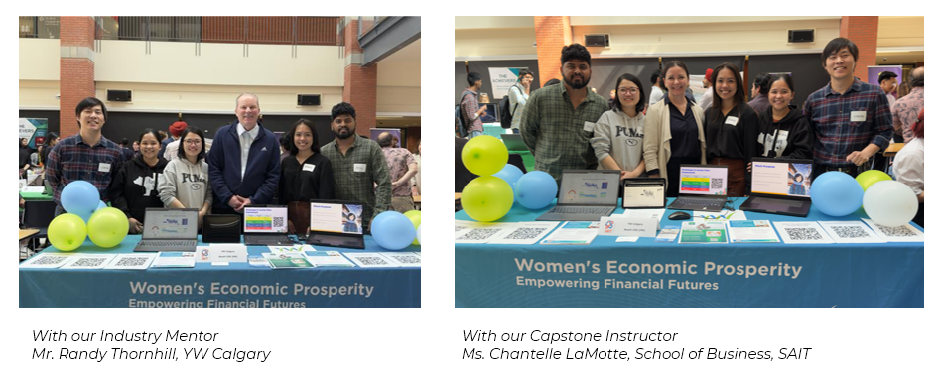

Figure 9: Capson Showcase 2025

# References:

Alberta’s homelessness response. Alberta.ca. (n.d.). Retrieved on 10 March 2025 <https://www.alberta.ca/homelessness-response>

Government of Alberta. (2025). Emergency Shelters Daily Occupancy AB [Dataset]. Open Data Alberta. Seniors, Community and Social Services. Retrieved on 05 March 2025. <https://open.alberta.ca/opendata/funded-emergency-shelters-daily-occupancy-ab#detailed>

SAIT. (2025). Module 4: Project Plan and Execution. In MNGT-257: Business Certificate Capstone [V3B]. D2L/Brightspace. <https://learn.sait.ca/d2l/le/content/741358/Home>

Shopify. (n.d.). *Competitive analysis: A step-by-step guide to understanding your competitors*. Shopify. Retrieved April 2, 2025, from <https://www.shopify.ca/blog/competitive-analysis#3>

The Digital Project Manager. (2023, March 15). *Project management methodologies made simple: A guide to understanding the most popular PM frameworks*. The Digital Project Manager. Retrieved April 2, 2025, from <https://thedigitalprojectmanager.com/project-management-methodologies-made-simple/>

# Appendices:

* Data Source: Emergency Shelters Daily Occupancy AB
* Pitch Presentation Slide Deck and Resource Sheet
* Team Members’ Contribution Template
* Status Meeting Templates
* Shiny App Code File
* Power Bi Dashboard File
* Action Plan File